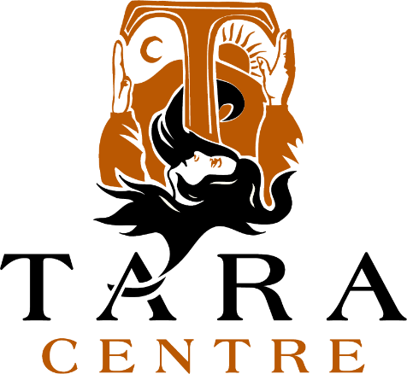

AUTUMN / WINTER 2021

“… in the service of healing, peace and holistic well-being.”

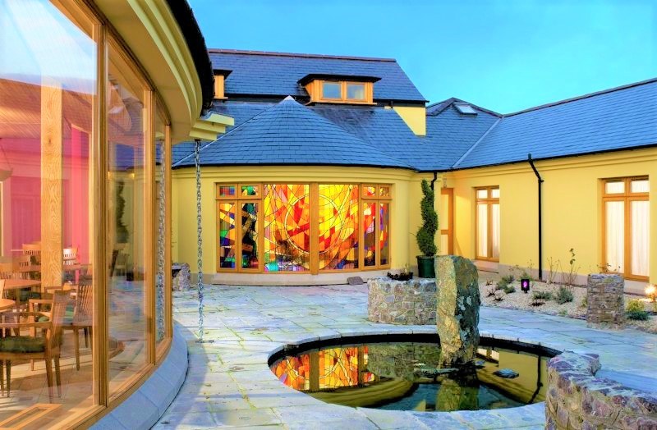
ABOUT TARA
The founding vision of the Tara Centre, opened in Omagh Town in 1996, now 25 years in existence, was inspired by a holistic philosophy which cherishes a sense of the sacred in all aspects of life and seeks to build a society where diversity can be experienced as enrichment and pain can be engaged with as the raw material of deep personal transformation.
More than all else, at the Tara Centre there is a deep and genuine commitment to supporting, in an appropriate manner, those who come through its doors to grow in an awareness of their personal, intrinsic worth as human beings and encouraging them to live their lives from this solid base.
Throughout the past 25 years, practical expression has been given to the aspirations of the Vision Statement by developing and delivering a wide range of healing and life-enhancing initiatives such as those identified in this brochure, all of which are experienced in the caring environment of a healing community and a warm welcoming building where the entire ethos breathes respect.
Testimonials abound to the fact that at the Tara Centre, people often find a new direction for their lives. They come in touch with deep inner resources, and are reminded that there are others who share their values about life and its meaning, thus finding inspiration in a communal quest.
“… in the service of healing, peace and holistic well-being.”

A Message from the Chairperson, Tara Board of Trustees/Directors

I have great pleasure in writing this, my first, message to you the Friends of Tara. On behalf of the Board of Trustees/Directors, the Co-Founders Maura and Mary and Members I wish to thank you for your continued support to the Tara Centre during these most challenging of times.

By way of a little information about myself I am a retired social worker, husband of Mary, father of two adult children and the grandparent of three little boys. It was in 1998 when assisting with the co-ordination of the response by voluntary organisations to the Omagh bomb that I first had contact with Tara in the form of Maura and Mary. Their commitment to the Omagh community left a lasting impression and in 2018 when they approached me to become a Trustee/Director I had no hesitation in agreeing to do so. In December 2020 I became chairperson of the Tara Board of Trustees/Directors

Where, you may ask, have Maura and Mary gone? In their booklet “Being on Pilgrimage- A Challenging but Rewarding Experience”, issued to Friends of Tara in 2020, they shared their plan to step down from Directorship of the Company in September 2020. This stepping down did indeed take place as planned. I can assure you however that both Maura and Mary continue to play a vital role as the Co-Founding Members of the Company in helping shape its future direction. As so eloquently described in their booklet they are walking with us on the “pilgrim discerning journey” and the nature of this journey was also very aptly illustrated in the booklet with the following quotation,

“Life is understood by looking backwards,
But it must be lived by looking forwards”
Soren Kierkegaard

In this our 25th anniversary year we, the Directors of the Company, will continue to honour the essence, ethos and values of Tara as lived by Maura and Mary and Tara will remain firmly “in the service of healing, peace and holistic well-being”. To this end I wish also to take the opportunity to thank Patricia McGlinn, General Manager, and all of the Tara staff for their commitment to the delivery of Tara services during the Covid pandemic and the creative ways in which we continue to reach out to those who avail of our services.

Importantly, our front door is again open and with our Autumn/Winter 2021 programme now launched we look forward once again to welcoming you in person to Tara where you will have an opportunity to “grow in awareness of this amazing universe – manifest and unmanifest- which sustains and embraces the whole community of life and within which, we, humans, discover and cherish our true identity and our life’s purpose”. (Extract from Tara’s Vision Statement).

Best wishes

Godfrey Young

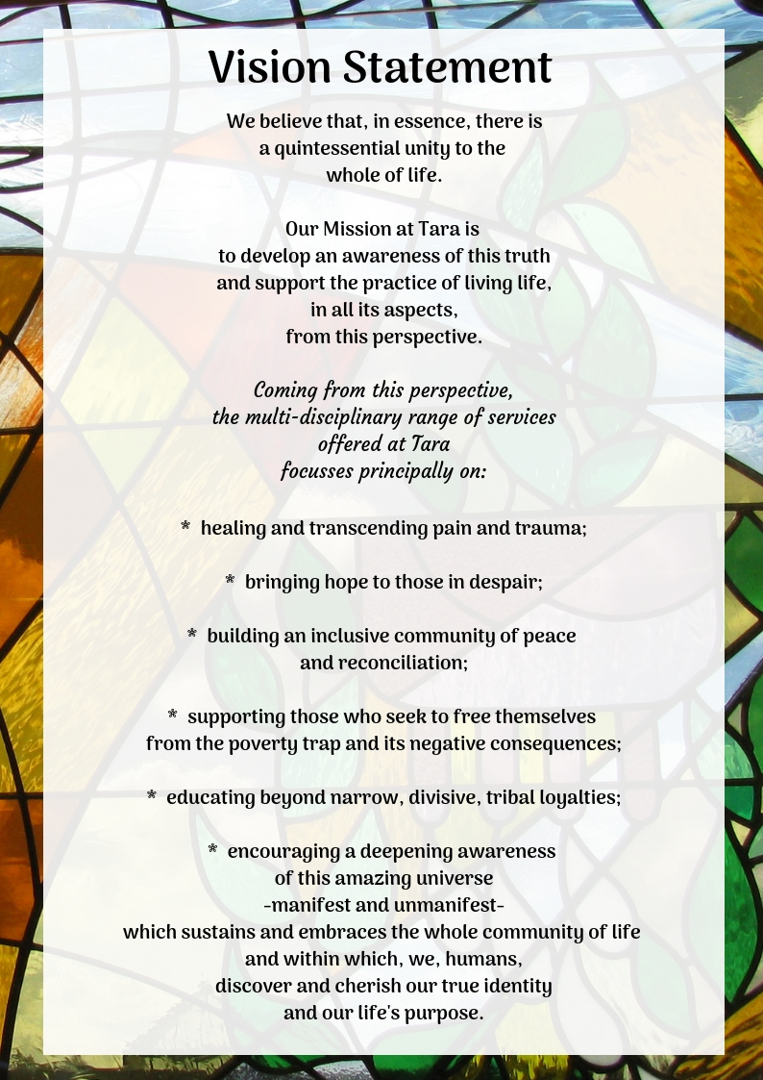

From the Desk of the General Manager

Dear Friends of Tara

Welcome to our new Tara Programme which will take us into Autumn/Winter 2021.

We are delighted to reach out to all our Friends with the much awaited news that we are continuing with the increasing return of physical presence in the Tara Centre, albeit in an incremental, cautious and safe manner. However, we are still very much aware of the difficult environment in which we operate and the ongoing challenges presented by the Covid 19 pandemic. We will continue to take account of the external environment and adhere to Government Guidelines in order to ensure, as far as we possibly can, the health and wellbeing of all those who come into our building. We thank you in advance for working with us and complying with our protocols - measures put in place for the health and safety of all.
Although our front door opened only recently, it has been business as usual here in Tara particularly in the delivery of Counselling, Psychotherapy and Art Therapy and the normal routine and operational activities. Many of you will also be aware of our move to embrace ZOOM in the provision of Seminars and Workshops as Webinars during Spring 2021 and Summer 2021 which proved to be very popular and much appreciated. We were delighted to commence our first face to face Programme with the Soul of Healing led by Maura and Mary in June 2021. We are keenly aware of a strong sense of longing, on behalf of both ourselves and our Friends, to return to the normal format of face-to-face presence in the Tara Centre
“ A timeless sacred place ……a sanctuary for all”

We are delighted to launch our Autumn/Winter 2021 Programme with physical presence in the Tara Centre. Unfortunately, due to the continued concerns relating to Covid 19, the number of participants will be necessarily limited for all workshops, seminars and

programmes. This will necessitate allocation of places on a first come first served basis and advance booking is therefore essential. In the unlikely event that you would need to cancel your place, we would ask that you notify Reception at the earliest opportunity, enabling us to offer your place to someone in waiting.
This brochure details the range of Therapeutic Services; our upcoming Workshops and Seminars; Programmes of Meditation and Yoga; and the Support Groups who meet here regularly at Tara.
Counselling/Psychotherapy and Art Therapy continue to be available as they have been throughout the pandemic with a mix of telephone, on-line via ZOOM and/or physical presence practice.
I would like to acknowledge the support received in my role as General Manager of the Tara Centre from the Co-Founders, Company Members, Directors and Staff and indeed the many Friends of Tara who have sent me messages of support and encouragement. I am truly grateful and feel privileged to be part of the Tara story particularly as we celebrate our 25th Anniversary. Unfortunately due to Covid, celebrations had to be postponed from 9th June 2021, (the actual foundation date), with a tentative date in September 2021 in mind. However, due to the continuing restrictions, it was decided to postpone our celebrations further until early 2022 when it is hoped we will be in a position to open our doors wide to invite as many of our Friends as possible and celebrate with Friends old and new. Details will be made available on our website and in our Spring 2022 brochure.
We hope you will find something of interest in our brochure and we look forward to welcoming you in person to the Tara Centre.

With warmest regards
Patricia

"Nothing can make our life, or the lives of other people, more beautiful than perpetual kindness."
Tolstoy

Financial considerations must not keep anyone away from here.

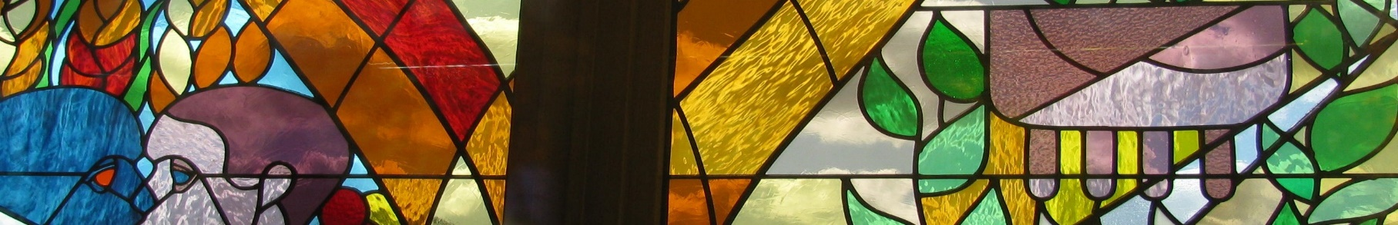
A Timeless Sacred Place…a Sanctuary for All

At Tara we have a strong, principled commitment to making all the Centre’s services available to anyone who can benefit from them, irrespective of a person’s ability to pay the stated cost.
We are a voluntary organization committed to providing services to the highest professional standards. All our costs are pitched at a minimum rate relative to the quality of the service on offer and the overall cost to us of providing that service.
Some, but not all of the services on offer, are subsidised by grants. We also receive donations/contributions from generous persons who share Tara’s conviction that the services on offer here make a worthwhile contribution to individual lives and to the community at large and whose financial circumstances at any given time permit them to support the work in this practical and much valued way.
The foregoing combined considerations influence the setting of fees for services on offer.
We are well aware however, that the fee set may be an obstacle to availing of the services for some people who could benefit from them and to whom we wish to extend a warm welcome.
In order to give expression to that warm welcome to such persons, we have a few options which we trust are fit for purpose, namely:
- payment by instalment cards are available on request at Reception;
- the £10.00 booking fee attached to certain services is usually paid in full in advance of the start date for the relevant programme; an instalment card may however be used for this purpose;
- in the event of neither of the arrangements detailed above meeting your need at a given time, you are cordially invited to make this known to the Receptionist who will arrange for you to discuss an alternative option.
A warm welcome, genuine respect and the utmost confidentiality is guaranteed to all

SERVICES & EVENTS
- On-Going Services
Financial Considerations 6
Counselling/Psychotherapy & Art Therapy 8/9
Complementary Therapies 9
- Seminars & Workshops
How to Make Informed Health Choices in these Difficult Times – Dr. Aileen O’Kane 10
Transforming Stress & Anxiety into Vitality – Michael O’Doherty 11
A Bio-Energy Healing Clinic 12
- On-Going Programmes
Yoga for Beginners & Intermediates – Heather Kemps 13
Soul of Healing – Mary Daly & Maura Twohig 14
Christmas Meditation 15
Meditating Together………………………………………………………………………………………………………………………………………………………15
- Support Groups Who Meet at Tara
PATHS: Living With Grief After Suicide 16
Omagh Men’s Support Group 16
- General Information
Bookshop and Lending Library 17
Facilities For Hire 17
Application Procedure: Counselling/Psychotherapy & Art Therapy 18
Application Procedure: Complementary Therapies 19
- Current Principal Sources of Funding
Sources of Funding 20
Fundraising Events.………………………………………………………………………………………………………………………………………………………..21
- Tara Centre Standing Order (Gift Aid)
Standing Order & Gift Aid 22/23

1. ON-GOING SERVICES
COUNSELLING/PSYCHOTHERAPY AND ART THERAPY

Theoretical orientations include:

- Art Therapy;
- CBT;
- Jungian Approach;
- Humanistic & Integrative;
- Rogerian Person Centred;
- Psychodynamic.
- Psychosynthesis

The therapists frequently exercise an eclectic approach to their work by drawing on additional modalities in which they have received specific training and which complement their basic orientation. These include Dream Work, Interactive Guided Imagery and others.

The approach at Tara is holistic and addresses a wide range of issues which include:
- abuse in all its forms: emotional, physical, psychological, sexual;
- bereavement: death, loss of any kind;
- relationship issues: early childhood issues, family of origin issues, partnership issues, social and occupational relationships;
- depression;
- trauma of all kinds;
- phobias;
- N.I. conflict related issues;
- spiritual crisis;
- crisis of any kind.

All Tara Centre Counsellors/Psychotherapists and Art Therapists are professionally trained, accredited by a recognised professional body*, and are committed to on-going professional development and supervision. *BACP, BABCP, IACP, BAAT, HCPC, BISS/ISST, NCS.
To make an enquiry regarding counselling / psychotherapy or art therapy, please contact Reception on (028) 82 250024. See page 18 of this Brochure for further details.

COUNSELLING/PSYCHOTHERAPY AND ART THERAPY (continued)

Following Covid 19 lockdown in March 2020, counselling/psychotherapy was provided by telephone. This continues along with online provision using the ZOOM platform. The Tara Centre has been increasing the availability of face to face counselling/psychotherapy in line with government guidelines relating to COVID-19. The Centre has in place Covid 19 protocols to protect the health and safety of all clients attending for face to face Therapy and the staff at the Centre. Protocols are communicated to each client by their assigned therapist before they come to the Centre for their first appointment. All Art Therapy appointments are face to face with COVID-19 protocols in place

COMPLEMENTARY THERAPIES
Complementary Therapy Treatments are a very significant dimension of the multi-disciplinary approach taken at the Tara Centre in support of holistic health, healing and general well-being.
Only professionally qualified practitioners are engaged at the Centre.

“When our mind – body system is in balance and we are connecting to our inner wisdom and intelligence, then we are most able to realise our full human potential and achieve our optimal state of being” Sheila Patel
PLEASE NOTE
Our Complementary Therapy Service is currently under review. We aim to resume this service by the end of November 2021.
Full details of Complementary Therapy Services will be available in due course on our
website www.taraomagh.com or by contacting Reception on 028 8225 0024

2. SEMINARS AND WORKSHOPS
“How to Make Informed Health Choices in These Difficult Times”
CONNECTING LIFESTYLE, HEALTH & WELL-BEING

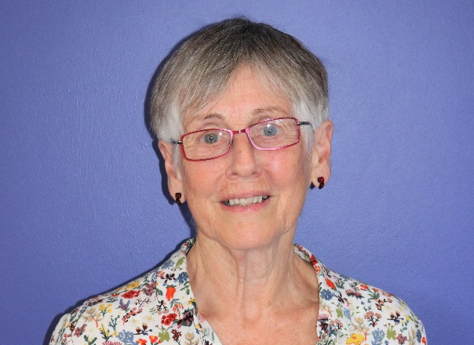
Dr Aileen O’Kane
We are delighted to welcome back Dr Aileen O’Kane to the Tara Centre in person. Dr Aileen practised conventional medicine from the early 70s to mid-90s. Through a personal illness in the early 90s she became very aware of the body/spirit/mind connection and subsequently studied many aspects of holistic health. For more than 20 years she has approached illness in a holistic way and uses the modalities of Ayurveda, Nutrition, Craniosacral Therapy and Emotional Freedom Technique in her Professional Work.
Never was a holistic approach to our health more needed. Covid has demonstrated that sick people are more vulnerable to the serious symptoms of this viral illness. Our immune system is amazingly designed to defend us against invading organisms. Many lifestyle choices and external situations affecting our lives can have detrimental effects on our immunity. In her presentation, Aileen will address some of these factors and suggest supportive choices and remedies.
Dates: Saturday 23rd October 2021
Time: 10.00am – 4.00pm (Registration from 9.00am – 10.00am)
Refreshments: Tea/Coffee & Scones on arrival from 9:00am / Lunch will be provided.
Cost: Your place is secured by payment of a £10 Booking Fee. VSS subsidises the rest of the cost for participants who meet the criteria. The cost is £30 for those who do not qualify for VSS.
Please see page 6 for financial considerations.
To Book: Places are limited due to Covid 19 restrictions. Prior booking is essential. Places will be allocated on a first come first served basis. Book your place by contacting Reception on 028 8225 0024

“If you concentrate on finding whatever is good in every situation, you will discover that your life will suddenly be filled with gratitude, a feeling that nurtures the soul”
Rabbi Harold Kushner

TRANSFORMING STRESS & ANXIETY INTO VITALITY
AN EXPERIENTIAL WORKSHOP ON TECHNIQUES FOR HEALING THROUGH THE USE OF THE BODY’S ENERGY/BIO-ENERGY
Michael O’Doherty
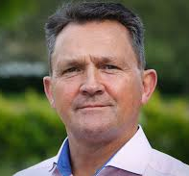
Michael O’Doherty is a pioneer in the field of healthcare with over 26 years’ experience in guiding many people back to health. He believes the time has come for change and family healthcare needs to become the central focus.
Testimony to the effectiveness of Michael’s energy work is provided by ‘Lord of the Dance’ celebrity Michael Flatley, among others, who credits Michael O’ Doherty with his return to the world stage with greater vigour than ever at a time when his spectacular career seemed to have come to an abrupt end.
At this two-day training programme, you will be given a basic understanding of tried and tested Bio-Energy techniques and an opportunity to learn these skills to help you and your family cope with stress and difficulties in life. Practice of the techniques will take place in pairs to facilitate experiential learning.

Dates: Saturday 27th & Sunday 28th November 2021
Time: Saturday 10.00am – 5.00pm/ Sunday 10.00am – 4.30pm
(Registration 9.00am–10.00am on Saturday 27th November)
Refreshments: Tea/Coffee & Scones on arrival from 9:00am / Lunch will be provided.
Cost: Your place is secured by payment of a £10 Booking Fee. VSS subsidises the rest of the cost for participants who meet the criteria. The cost is £60 for those who do not qualify for VSS.
Please see page 6 for financial considerations.
To Book: Places are limited due to Covid 19 restrictions. Prior booking is essential. Places will be allocated on a first come first served basis. Book your place by contacting Reception on 028 8225 0024
Note: Attendance throughout the full two-day programme is essential. Please wear comfortable clothing. Due to Covid 19, the sanitising/washing of hands and wearing of masks and/or visors is a requirement during practice of techniques.
“ I think that energy, and the use of energy in healing, will be the biggest frontier in medicine over the next decade.”
Dr. Mehmet Oz

A BIO-ENERGY HEALING CLINIC

Michael O’Doherty
The Tara Centre is now an established base in Northern Ireland for Michael O’Doherty and his one to one Bio-Energy Healing Treatment Clinic. This is a privately run Clinic which is managed by Michael and his own team.
For the Autumn/Winter 2021 Programme, Michael will be here on the following dates:
Dates: Monday 29th November, Tuesday 30th November, Wednesday 1st December & Thursday 2nd December 2021
ONE-TO-ONE TREATMENT
“Illness begins in your body when your bio-energy system gets blocked or becomes imbalanced. The first step is to get your energy system balanced and flowing correctly and this in turn triggers the process of healing in your body.
Both my practitioners and I work with a limited number of people on a one to one basis at my clinics in Ireland and the UK where great time and effort is taken to ensure the cause of your health issues are clearly identified and the correct strategies are put into place. Emotional stress, chronic fatigue, digestive disorders, children’s health issues including colic, asthma, obesity, diabetes, eczema etc. just to name a few of the conditions that people attend my clinic with”.

Booking Clinic Appointments

All enquiries and transactions in relation to attending Michael’s private clinic at Tara are to be made directly by contacting Michael’s clinic in Ennis, Co. Clare.

Note: The Tara Centre plays no part in this process but we recommend it unreservedly.

Contact Details:
Telephone: 00353 65 6841844
Mobile: 00353 87 6721888
E: info@michaelodoherty.com

3. ON-GOING PROGRAMMES
YOGA
Heather Kemps

Yoga is a very old tradition which has much to offer in today’s lifestyle, helping us to feel more peaceful in a chaotic world. It helps to harmonize and balance the mind, body and emotions through using postures, breath and relaxation techniques. Yoga is for everyone. The practice of yoga is a tool to help individuals develop self-awareness, thus enabling them to live a more balanced and fulfilling life.

Heather Kemps has been delivering Yoga Courses at the Tara Centre since the beginning. Her approach stays true to the Indian tradition of Yoga in its original form with a view to healing of both mind and body. It includes a strong focus on exercises to help with not only stress and anxiety but also digestive health.
Those who practice yoga at Tara are advised to wear loose clothing. It is advisable that expectant mothers wait until after the 12th week of pregnancy before attending Yoga sessions.
Special Notice:
We are keen to resume our Yoga Programme for the Autumn/Winter Term 2021.
Due to Covid 19, there will be limited numbers per class and only 2 classes per week - 1 beginners’ class and 1 intermediate class.
The Programme will run for 9 weeks.

We regret we will be unable to provide yoga mats due to Covid 19. Please ensure that you bring your own mat and a blanket or sleeping bag.
YOGA FOR BEGINNERS  Dates: Wed 6th Oct. – Wed 1st Dec  Times: 10.30am–12.00pm  Cost: £45 (9 weeks) | YOGA FOR INTERMEDIATES  Dates: Thurs 7th Oct - Thurs 2nd Dec  Times: 7.00pm – 8.30m  Cost: £45 (9 weeks)

TO BOOK: Places are limited due to Covid 19 restrictions. Prior booking is essential. Places will be allocated on a first come first served basis. Book your place by contacting Reception on 028 8225 0024

“If you become identified with consciousness, you will experience everyone as yourself. This is what yoga means.” Sadhguru

MEDITATION – A WAY OF LIFE
THE SOUL OF HEALING
Mary Daly & Maura Twohig

For over 25 years, the Tara Centre Co-Founders have hosted these soul-nourishing one day gatherings at the Centre. They have become cherished occasions of “…healing, peace and holistic well-being” for the many seasoned meditators who attend, creating and sharing the ethos which enriches the quality of life at truly transformational levels.

Attendance at these one day intensives is open to anyone who has ever followed the Meditation and Mindfulness course at this Centre.

Dates: Saturday 16th October 2021
Time: 11.30am – 5.30pm (Registration from 11.00am – 11.30am)
Refreshments: Tea/Coffee & Scones on arrival from 11.00am / Lunch will be provided.
Cost: Contributions
To Book: Places are limited due to Covid 19 restrictions. Prior booking is essential. Places will be allocated on a first come first served basis. Book your place by contacting Reception on 028 8225 0024

“The purpose of meditation is to make our mind calm and peaceful. If our mind is peaceful, we will be free from worries and mental discomfort, and so we will experience true happiness. But if our mind is not peaceful, we will find it very difficult to be happy, even if we are living in the very best conditions”.
Kelsang Gyatso

CHRISTMAS MEDITATION
Mary Daly & Maura Twohig

The annual Christmas Meditation provides an opportunity to connect at soul level with the true meaning and message of Christmas in its original context as it impacts on day to day living in the 21st century.

This is a truly unique occasion and places at this event are much sought after. In the unlikely event that you would need to cancel your place, we would ask that you notify Reception at the earliest opportunity, enabling us to offer your place to someone in waiting.

Dates: Saturday 11th December 2021
Time: Saturday 3.30pm – 8.00pm
(Registration 3.00pm–3.30pm)
Refreshments: Tea/Coffee & mince pies on arrival from 3.00pm / Dinner will be provided.
Cost: Your place is secured by payment of a £10 Booking Fee. Contributions on the day.
Please see page 6 for financial considerations.
To Book: Places are limited due to Covid 19 restrictions. Prior booking is essential. Places will be allocated on a first come first served basis. Book your place by contacting Reception on 028 8225 0024

MEDITATING TOGETHER
Mary Daly & Maura Twohig

The established Tara Centre Meditation Group will resume meeting on Tuesday mornings at 10.30am, led by Maura and Mary, commencing on Tuesday 5th October 2021. Anyone who has followed the Meditation / Mindfulness Course for Beginners at the Tara Centre is welcome to join this group. Please contact Reception prior to doing so.

Date: Tuesday mornings commencing Tuesday 5th October 2021
Time: 10.30am–12 noon
Refreshments: Refreshments provided
Cost: Contributions welcome
To Book: Places are limited due to Covid 19 restrictions. Prior booking is essential. Places will be allocated on a first come first served basis. Book your place by contacting Reception on 028 8225 0024

4. SUPPORT GROUPS WHO MEET AT TARA
LIVING WITH GRIEF AFTER SUICIDE (PATHS)

PATHS is an inter-denominational voluntary group formed to support families and individuals bereaved by suicide. Members of the group form an emotional bond of friendship arising from their shared experience of having suffered similar shock, confusion and loss in their lives. It is within this safe and confidential environment that PATHS members share their pain and grief.
Special Notice Autumn/Winter Term 2021
PATHS Meetings will now be held on the 2nd Tuesday of each month 8.00pm – 9.30pm
The first meeting will be held on Tuesday 12th October 2021.
For further information, contact Jimmy on 07879 414385.

OMAGH MEN’S SUPPORT GROUP
The group offers men a safe and secure space where they can talk about their emotions, find help in managing the stress in their lives and explore possible solutions to life’s problems. Issues raised can include relationships, raising children, work, feelings of failure and ambition, loss, health and money worries.

Meetings are normally held on Monday nights, 7.30pm -9.30pm.
(First Meeting – Monday 11th October 7.30pm – 9.30pm

For further information, contact Gerry on 07799 472968

Disclaimer: While management genuinely appreciates the value of the services offered at the Tara Centre by both PATHS and The Omagh Men’s Support Group, we wish to point out that both groups are self-governed and as such function entirely independently of the Tara Centre governance system. Accordingly, the Centre carries no responsibility for any aspect of the life and activities of these groups.
This disclaimer also extends to all other persons or groups who use the Centre on an independent basis from time to time
Groups are responsible for ensuring Tara Centre Protocols are adhered to.
5. GENERAL INFORMATION

BOOKSHOP AND LENDING LIBRARY
The Bookshop and Lending Library are temporarily unavailable due to Covid 19. However, if there is a specific book you wish to purchase please contact us and we will happily check to see if that book is available for collection.
Our Bookshop has been “on ice” for some time. Please check our website for any updates. In the meantime, we continue to stock a range of resources that encourage “...healing, peace and holistic wellbeing”. The holistic approach to health and well-being, which is a hallmark of life at the Tara Centre, is reflected in the material in stock at any given time in the Bookshop. The range of authors and themes represents a great diversity of perspectives on topics addressed. *

*Disclaimer: Management does not necessarily subscribe to views/opinions expressed in all material in stock in the Bookshop and/or the Lending Library.
Our popular Gift Vouchers are available at Reception for Complementary Therapies (when this service resumes), Attendance at Tara Centre Programmes, and the purchase of books and items for sale, making perfect to give as a Christmas gift.
FACILITIES FOR HIRE
The Centres facilities for hire are temporarily unavailable due to the Covid 19 Pandemic.
In normal times the range of available facilities are as follows:
Conference Hall
- State-of-the-art facilities, fully air-conditioned and with disabled access
- Ideal for large groups, conferences, exhibitions, seminars and workshops
- Video conference capability. Access to all media using ceiling mounted digital projectors to display laptop presentations, DVD, VHS on 2 screens
- Wi-Fi Internet access. Induction loop system
- Daylight and dark electronically controlled
Dining Room
- Spacious, attractive, light-filled dining room overlooking the courtyard.

Provision of Catering Facilities
- Tara is well known for the warmth, hospitality and the quality of the catering provided is part of that offering.

APPLICATION PROCEDURE
COUNSELLING/PSYCHOTHERAPY AND ART THERAPY

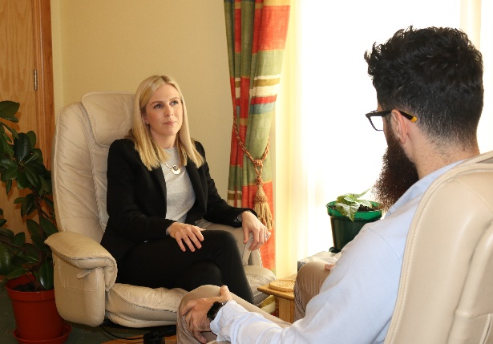
Persons who seek a counselling/psychotherapy or art therapy appointment are asked to leave their name, (first name if preferable), and telephone number with the Receptionist for the attention of the Co-Ordinator of Therapeutic Services, (COTS). No details regarding the applicant’s issue(s) should be given at this stage.

The Co-Ordinator of Therapeutic Services will return the applicant’s call as soon as possible. He will give an indication, based on current demand for services and therapist availability, of the length of time the applicant may have to wait for an appointment. An available relevant counsellor/psychotherapist or art therapist, as the case may be, will be assigned to each applicant. The assigned counsellor/psychotherapist or art therapist will contact the applicant/client to arrange the first appointment.

Tara Centre has in place Covid 19 protocols to protect the health and safety of all clients attending for face to face Counselling/Psychotherapy/Art Therapy and the staff at the Centre. These will be communicated to each client by their assigned therapist before they come to the Centre for their first appointment.
Cancellation Policy: The Centre’s cancellation policy will be communicated to each client by their assigned therapist.

Emergency/Crisis Situations

In Emergency/Crisis situations every effort will be made that applicants in these circumstances will be contacted by the Co-Ordinator of Therapeutic Services within 24 hours and appropriate support provided in accordance with the Centre’s resources.

Cost: A sliding scale is in operation for payment for counselling/psychotherapy and art therapy. Fully funded places or places at a reduced cost are offered to persons who qualify under the conditions of relevant available grants. Each case is dealt with individually through a process of consultation between the client and the assigned counsellor/psychotherapist or art therapist.
15 “A timeless sacred place…

Note: A certain number of counselling/psychotherapy sessions are currently funded by VSS grant for persons who qualify. For further details, please contact the Co-ordinator of Therapeutic Services on 028 8225 0024

APPLICATION PROCEDURE (continued.)
20 “A timeless sacred place…

COMPLEMENTARY THERAPIES
PLEASE NOTE
Our Complementary Therapy Service is currently under review. We aim to resume this service by the end of November 2021.
Full details of Complementary Therapy Services will be available in due course on our
website www.taraomagh.com or by contacting Reception on 028 8225 0024

In normal times the following process would apply:

Grant Aided Appointments
The Tara Centre is grateful to the Victims & Survivors Service, (Victims and Survivors Programme, VSS), for grant aid that enables us to deliver fully funded Complementary Therapies to those who meet the relevant criteria. Contact the Receptionist who will assist you in making an application. The completed form will be passed onto the Co-Ordinator of Therapeutic Services whose responsibility it is to approve the application. The Co-Ordinator will assign a relevant available therapist to persons whose application has been approved. The assigned therapist will make direct contact with the applicant and arrangements will be made for her/him to receive the agreed therapy as soon as a place becomes available.

Appointments on a Fee-Paying Basis
Where a grant is not available, or in the case of persons who do not meet the grant aid criteria, appointments can be arranged on a fee paying basis. In the event of the fee being prohibitive in individual cases, a reduced fee will be considered by the Co-Ordinator of Therapeutic Services on request.

Cancellation Policy: The Centre’s cancellation policy will be communicated to each client by their assigned therapist.
Special Rates of Payment
- At Tara we have a strong principled commitment to making the Centre’s services available to anyone who can benefit from them, irrespective of a person’s ability to pay.
- All costs are pitched at a minimum rate relative to the quality of service on offer.
- Payment by instalments is facilitated at Reception, on request, to ensure no one is
excluded on grounds of cost.
- A personally affordable price can be directly worked out on a one-to-one basis, on request, through consultation with the General Manager.

6. CURRENT PRINCIPAL SOURCES OF FUNDING
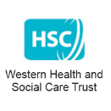
- Victims & Survivors Service
- WHSCT
- Department of Foreign Affairs
- Philanthropic Donations (large and small)
- Personal Donations - Made from time to time to the Centre which are frequently accompanied by a request from these generous benefactors to desist from publishing their details. Their contributions are recorded, responsibly used and most gratefully received.

- Personal Donations - Through Standing Orders & Gift Aid
(Detailed records held at the Centre)

- Donations from Organisations - Through other sources, locally and further afield, with our sincere gratitude, we acknowledge, in the last eighteen months, the following;
- Darkness into Light, Pieta House
- Primark, Omagh
- Omagh St. Endas (Health & Well Being Committee)
- Brain Garrity, Director at BGI NI
- Ultra Building Products Ltd
- Smile.Amazon.co.uk
Other Significant Support Towards Sustainability:
  - Sisters of Mercy, Northern Province
  - Presentation Sisters, North East Province

The most significant support provided to the Tara Centre by the Sisters of Mercy and the Presentation Sisters is the lease of the premises, jointly owned by them, to the Company, free of charge.

“Thank you, sincerely, for whatever way you choose
to support the good work of Tara.”

TARA CENTRE FUNDRAISING EVENTS

Due to Covid 19, our fundraising opportunities have been limited over the last 18 months. However, our grateful thanks to Gemma Donnelly of Bumble & Blue who offered to design and create a special range of candles in conjunction with Tara to celebrate our 25th Anniversary 2021. All profits are being donated to Tara.

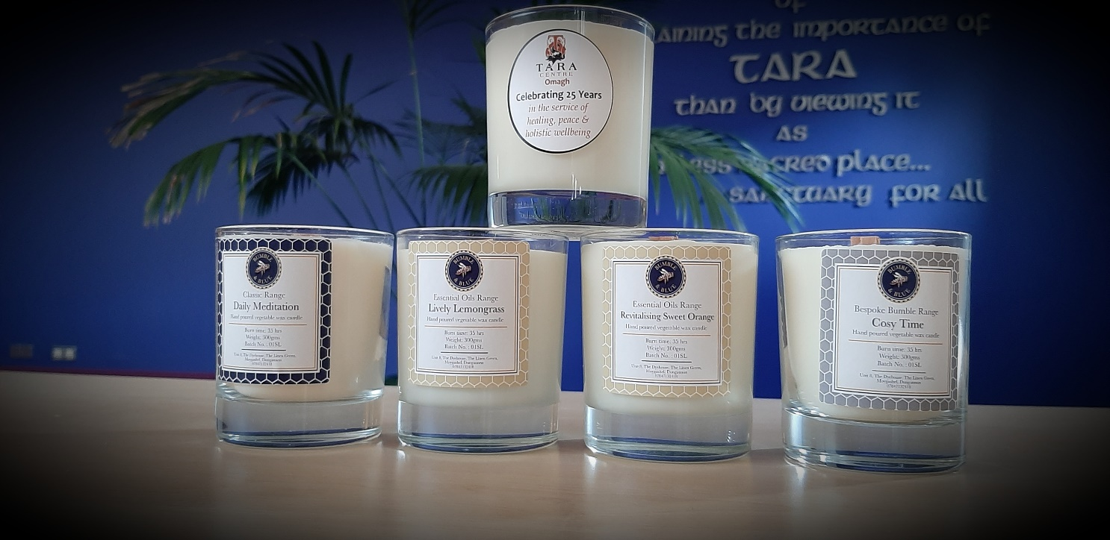

Candles are currently only available directly from Gemma. Please contact her as follows:
Website: www.bumbleandblue.com
3 Facebook Pages: Gemma Donnelly, Bumble&Blue, Bumble&Blue Interiors
Instagram: @bumbleandblue and @bumbleandblueinteriors
Email: bumble&blue@icloud.com
Text messages on: 07754830170
WhatsApp: (0747) 132418

“Generosity is the most natural outward expression of an inner attitude of compassion and loving-kindness”
Dalai Lama

7. TARA CENTRE STANDING ORDER (& GIFT AID)

YOU CAN MAKE A DIFFERENCE

This is one of Tara’s very effective sustainability initiatives of which all of you can become a part.
Your Personal Invitation to do so.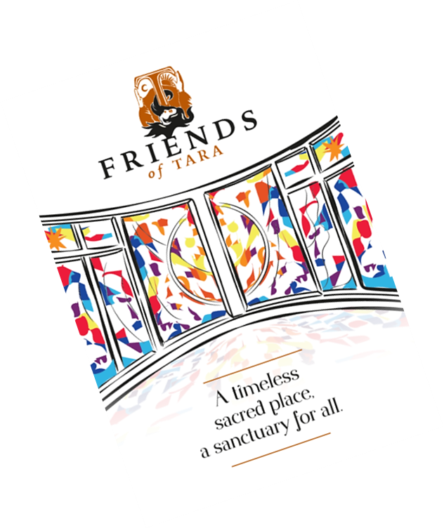
A core group of dedicated fundraisers, led by Company Director and Treasurer, Marian Harte, promote and assist with the management of the Standing Orders and Gift Aid initiative, ensuring that your contributions realise the maximum benefit for the Centre, enabling us to do what we do. We are working towards a target of 1000 members for this source of funding.
We are deeply grateful to all who already contribute generously towards the Centre’s financial sustainability through the Standing Order (& Gift Aid Initiative) and we look forward to welcoming many more of you on board in response to this, your Personal Invitation.
The Standing Order form is attached to the next page, containing all the relevant information you need to respond to your Personal Invitation, or you can contact Reception on 028 82 250024 or visit our website www.taraomagh.com

STANDING ORDER MANDATE
CLIENT BANK CLIENT NAME & ADDRESS
The Manager: ………………………………………………….… Name: …………………………………………………………..
Address: …………………………………………………………….. Address: ……………………………………………………….
Town: ………………………………………………………………… Town: ……………………………………………………………
Postcode: …………………………………………………………… Postcode: ……………………………………………………..
Date: …..…../…..…../…...……. (DD/MM/YYYY)
Dear Sir/ Madam,

I/We hereby authorise you to debit my/our account detailed below:

SORT CODE ACCOUNT NUMBER

With the sum of: On:
£ ………………………………………………………………………. ………………………………………. of every month
With effect from: …..…../…..…../......……. (DD/MM/YYYY)
Please write amount in block capitals: ………………………………………………………………………………………….

PAYEE: Tara Centre The COP Account
BANK: First Trust Bank, 8 High Street, Omagh
SORT CODE: 93-81-30
ACCOUNT NUMBER: 15828-183

Yours faithfully,
SIGNED ………………………………………………………………. NAME…………………………………………………………..
(Donor)
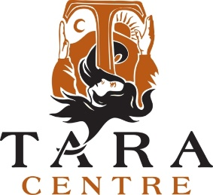

Please tick this box if you wish The Tara Centre to
Receive Gift Aid from your donation.
(Gift Aid enables us to reclaim tax on your payment)
You must pay an amount of Income Tax and/or Capital Gains Tax at least equal to the tax that the charity reclaims on your donations in the appropriate tax year (currently 25p for each £1 you give).

“As we move through this beautiful and troubled world,
may we vow to be a beacon of peace,
a fearless carrier of respect and loving kindness for all life,
a teller of truth,
a voice for justice,
a protector of those who are vulnerable or targeted.
May the power of wisdom, integrity and compassion be our guide.”
Jack Kornfield

