THE TARA CENTRE, OMAGH

This Centre was founded in 1996. It is a Registered Charity governed as a Company Limited by Guarantee.
The founding vision was inspired by a holistic philosophy of life which cherishes a sense of the sacred in all aspects of life and seeks to build a society where diversity can be experienced as enrichment and pain can be engaged with as the raw material of deep personal transformation.
The Core Values and Ethical Principles which inform all aspects of life at the Centre find expression in the Vision Statement.
Throughout the past 25 years, practical expression has been given to the aspirations of the Vision Statement by developing and delivering a wide range of healing and life-enhancing initiatives. These healing and life-enhancing initiatives are offered in the caring environment of a healing community and a warm welcoming building where the entire ethos breathes respect.
Whilst some services were impacted by the Covid 19 pandemic in the first instance, we are pleased to report that all have now resumed with face-to-face presence in the Centre. We continue to observe Covid 19 guidelines and restrictions in the interest of keeping our visitors and staff safe.
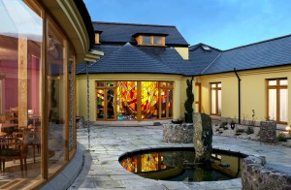

“… in the service of healing, peace and holistic well-being.”

