“....in the service of healing, peace and holistic wellbeing”
Summer 2022
www.taraomagh.com
Open Monday –Thursday 9.00am to 5.00pm (currently closed for lunch 1.00pm – 2.00pm). Also open at other times as indicated below.

ONGOING SERVICES AVAILABLE
COUNSELLING/PSYCHOTHERAPY ART THERAPY COMPLEMENTARY THERAPIES
WORKSHOPS, SEMINARS AND OTHER EVENTS ON OFFER THIS TERM
WE WARMLY INVITE YOU TO JOIN US IN THE TARA CENTRE:
- Meditating Together

Mary Daly and Maura Twohig
Date: Tuesdays, starting Tuesday 26th April to Tuesday 5th July 2022
Time: 10.30 am – 12 noon
(Open to anyone who has followed the Tara Centre Meditation/Mindfulness Course for Beginners)

- Meditation “Soul of Healing”
Mary Daly and Maura Twohig
Date: Saturday 14th May 2022
Time: 11.30am – 5.00pm (registration 11.00am – 11:30am)
(Open to anyone who has followed the Tara Centre Meditation/Mindfulness Course for Beginners)

- “Lifestyle Adjustments to Optimise and Take Responsibility for Our Own Health”
Dr. Aileen O’Kane will be looking at key factors which must be part of our lifestyle to remain healthy.
Date: Saturday 11th June 2022
Time: 10.00 am – 4.00pm (Registration 9.00am – 9.45am)

- Meditation “Soul of Healing”
Mary Daly and Maura Twohig
Date: Saturday 18th June 2022
Time: 11.30am – 5.00pm (registration 11.00am – 11:30am)
(Open to anyone who has followed the Tara Centre Meditation/Mindfulness Course for Beginners)

- Yoga for Beginners and Intermediates
Heather Kemps – 8 weeks
Beginners: 10.30am – 12 noon starting Wednesday 11th May to Wednesday 29th June 2022
Intermediates: 7.00pm – 8.30pm starting Thursday 12th May to Thursday 30th June 2022

TO BOOK YOUR PLACE ON ANY OF THE ABOVE PLEASE CONTACT
RECEPTION ON 02882 250024

Prior booking is essential for all of the above. Places will be allocated on a first come first served basis.
- Darkness into Light- Dromore

We are most grateful that Darkness into Light - Dromore, in conjunction with Pieta House Dublin has chosen Tara Centre as their partner charity once again this year. DIL2022 welcomes the return of in person walks which will take place at sunrise on Saturday 7th May 2022.
Registration for DIL2022 is available at www.darknessintolight.ie
Date: Saturday 7th May 2022
Time: 4.00 am
Location: Dromore Sports Complex

Support Groups who meet at Tara will hold their meetings in accordance with the group schedule.
Premises for Hire/Bookshop and Lending Library remain unavailable at this time. We are reviewing this on an ongoing basis.

Victims and Survivors Grant available for some of the costs associated with the provision of counselling/psychotherapy, complementary therapies and some workshops/seminars

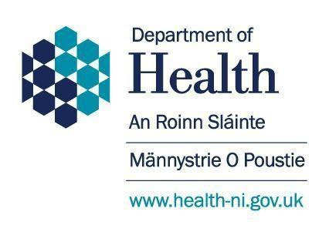
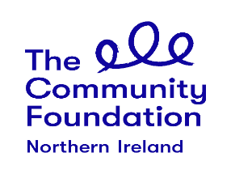

NOTE: FOR FURTHER DETAILS ON ANY OF THE ABOVE PLEASE USE THE CONTACT DETAILS LISTED BELOW
TARA CENTRE, 11 HOLMVIEW TERRACE, OMAGH, BT79 0AH
TEL: 02882 250024
EMAIL: info@taraomagh.com OR WEBSITE www.taraomagh.com

