Dear Friend of Tara,
We are pleased to present our programme of events for Autumn/Winter 2022. Maura and Mary will lead a range
of relaxing and soul nourishing events such as Meditating Together on a Tuesday morning, Soul of Healing and
the much loved Christmas Meditation in December. Declan Coyle will be with us delivering the world acclaimed
‘Green Platform’ and Aileen O’Kane will present a two part workshop on the ancient practice of Ayurveda.
To conclude, we will have an additional beginners yoga class on a Thursday evening, classes have been increased
to 30 participants and the programme will run for 10 weeks. We hope you find something of interest in our
Autumn/Winter programme and we hope to see you soon! For your continued support, we say thanks, thanks
and thanks again.

Autumn/Winter 2022
Open Monday –Thursday 9.00am to 5.00pm (currently closed for lunch 1.00pm – 2.00pm)
Also open at other times as indicated below.
ONGOING SERVICES AVAILABLE
COUNSELLING/PSYCHOTHERAPY ART THERAPY COMPLEMENTARY THERAPIES
WORKSHOPS, SEMINARS AND OTHER EVENTS ON OFFER THIS TERM
WE WARMLY INVITE YOU TO JOIN US IN THE TARA CENTRE:
- Meditating Together

Mary Daly and Maura Twohig
Date: Tuesdays, starting Tuesday 20th September 2022
Time: 10.30 am – 12 noon
Cost: Contributions welcome on the day
We are delighted to be able to confirm that Mary and Maura will be at Tara on Tuesday
mornings to be with those who wish to continue the practice of meditating together at Tara.
Persons who are familiar with the generic approach to meditation as taught & practised at Tara
are welcome to be part of the group. Please contact reception with any queries.

- Meditation “Soul of Healing”
Mary Daly and Maura Twohig
Date: Saturday 1st October 2022
Time: 11.30am – 5.00pm (registration 11.00am – 11:30am)
Cost: Contributions welcome on the day
(Open to anyone who has followed the Beginners Meditation course at Tara or has been part of the Tuesday Meditation Group.)

- Yoga for Beginners and Intermediates
Heather Kemps – 10 weeks
(30 places available per class)
Cost: £50 for full course
Beginners: 10.30am – 11.45am starting Wednesday 28th September to Wednesday 30th^{th} November 2022
Beginners: 6.15pm – 7.30pm starting Thursday 29th September to Thursday 1st December 2022
Intermediates: 8.00pm – 9.15pm starting Thursday 29th September to Thursday 1st December 2022

- “The Green Platform – Simply Life Changing”
Declan Coyle is back by popular demand to deliver his worldwide acclaimed programme, The Green Platform.
(60 places available)
Date: Saturday 22nd October and Sunday 23rd October 2022
Time: 10.00 am – 4.00pm (Registration 9.00am – 9.45am on Saturday 22nd October)
Cost: Your place is secured by a £10 booking fee. VSS subsidises the rest of the cost for participants who
meet the criteria. The cost is £60 for those who do not qualify for VSS.

- Meditation “Soul of Healing”
Mary Daly and Maura Twohig
Date: Saturday 5th November 2022
Time: 11.30am – 5.00pm (registration 11.00am – 11:30am)
Cost: Contributions welcome on the day
(Open to anyone who has followed the Beginners Meditation course at Tara or has been part of the Tuesday Meditation Group.)

- An Introduction to Ayurveda
Dr Aileen O’Kane
Ayurveda is an ancient system of healing which is rooted in the principle that mind, body and spirt are
inextricably linked. This is a two part workshop and attendance at both sessions is required to maximise the
experience.
(40 places available)
Date: Saturday 19th November and Saturday 26th November 2022
Time: 10.00am – 4.00pm (Registration 9.00am – 9.45am)
Cost: Your place is secured by a £10 booking fee. VSS subsidises the rest of the cost for participants who
meet the criteria. The cost is £60 for those who do not qualify for VSS.

- Christmas Meditation
Mary Daly and Maura Twohig
(60 places available)
Cost: Your place is secured by a £10 booking fee. Contributions are welcome on the day.
Date: Saturday 10th December 2022
Time: 3.30pm – 8.00pm (registration 3.00pm – 3.30pm)
(Open to anyone who has followed the Beginners Meditation course at Tara or has been part of the Tuesday Meditation Group.)

PRIOR BOOKING IS ESSENTIAL
TO BOOK YOUR PLACE ON ANY OF THE ABOVE PLEASE CONTACT
RECEPTION ON 02882 250024

Support Groups who meet at Tara will hold their meetings in accordance with the group schedule.
Victims and Survivors Grant available for some of the costs associated with the provision of
counselling/psychotherapy, complementary therapies and some workshops/seminars

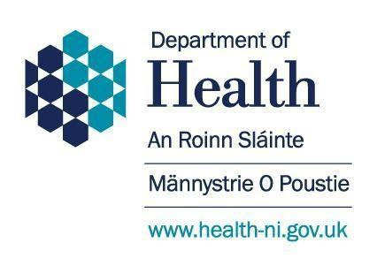
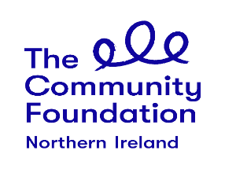

NOTE: FOR FURTHER DETAILS ON ANY OF THE ABOVE PLEASE USE THE CONTACT DETAILS LISTED BELOW
TARA CENTRE, 11 HOLMVIEW TERRACE, OMAGH, BT79 0AH
TEL: 02882 250024
EMAIL: info@taraomagh.com OR WEBSITE www.taraomagh.com

