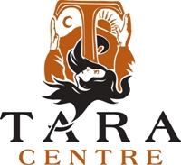
The Tara Centre is a leading Registered Charity, governed as a Company Limited by Guarantee, and based in Omagh, Co. Tyrone. It has delivered a wide range of holistic healing interventions and associated educational programmes “in the service of healing, peace and holistic wellbeing” for the past 29 years. We seek to recruit the post of:
Business Development and Finance Officer
Location: Tara Centre, Omagh
Salary: £29,064 – £31,022 per annum
Hours: Full-time (37.5 hrs/week) – Part-time options considered
Contract: Permanent
Are you passionate about making a difference through strong financial stewardship and creative income generation? Tara Centre is seeking a Business Development & Finance Officer to play a pivotal role in managing our finances and driving sustainability.
What you’ll do:
- Oversee day-to-day financial operations.
- Prepare budgets, forecasts, and reports for management, funders, and the Board.
- Research and secure funding opportunities and develop income generation initiatives.
- Contribute to strategic planning and promote financial awareness across the team.
If you have strong organisational skills, attention to detail, and a commitment to our vision of healing and community wellbeing, we would love to hear from you.
What We Offer
- A values-led environment rooted in healing, peace, and holistic wellbeing.
- Flexible working arrangements to support work-life balance.
- Competitive salary aligned with responsibility and sector benchmarks.
- Opportunity to make a real impact on the sustainability of a respected community organisation.
- Collaborative and supportive team culture, where your contribution is valued.
- Professional development opportunities, including training relevant to finance, compliance, and income generation.
- Meaningful work that directly supports life-changing programmes.

FOR ALL JOB DESCRIPTIONS AND TO OBTAIN APPLICATION PACKS
PLEASE VISIT OUR WEBSITE

www.taraomagh.com/jobs

Completed Application Forms and documentation must be returned by 12 noon, Monday 12th January 2026, as follows:
- Electronically completed application forms and documentation should be forwarded to recruitment@taraomagh.com
OR
- Hard copies of application form and documentation should be sent to:
General Manager, Tara Centre, 11 Holmview Terrace, Omagh, BT79 0AH.
It is anticipated that interviews will take place at the Tara Centre, 11 Holmview Terrace, Omagh on Friday, 23rd January 2026.

CANVASSING WILL AUTOMATICALLY DISQUALIFY
The Tara Centre is an Equal Opportunities Employer

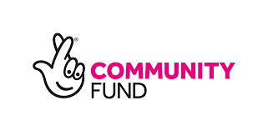
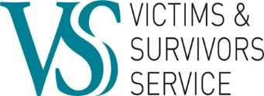
Posts are part-funded by VSS and the People and Communities Fund:

